Homework #9

Zhengwu zhang

1. (a)

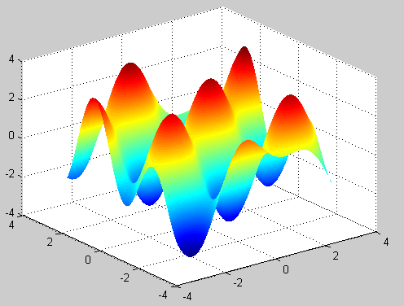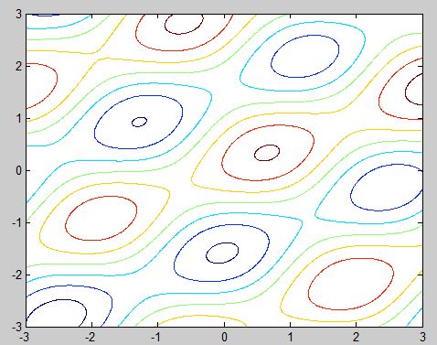

Figure 1 function plot Figure 2 Counter

(b)

a = 0.1

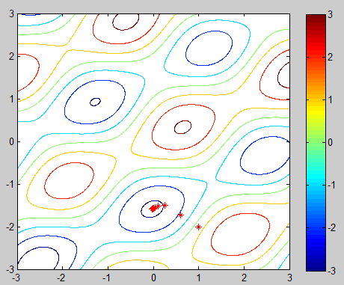 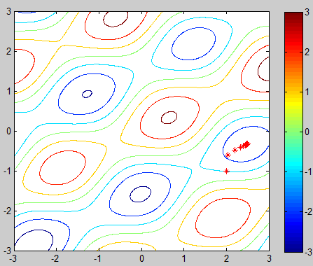

Initial (1,-2) Initial(2,-1)

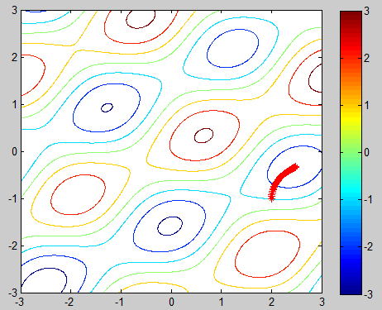 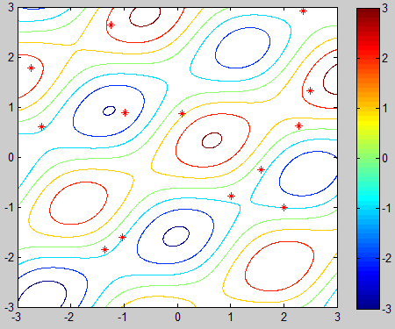

a=0.01 a = 1

when a=0.01, the steps is very small. When a = 1, the steps is very large, the program could not find the right max/min location since the steps is so large.

(c)

A = 0.1

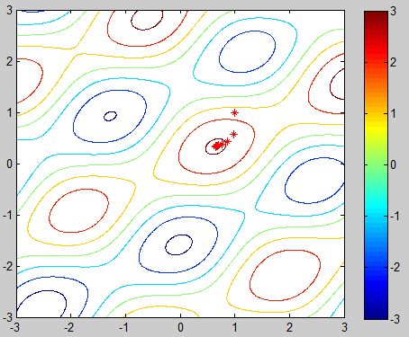 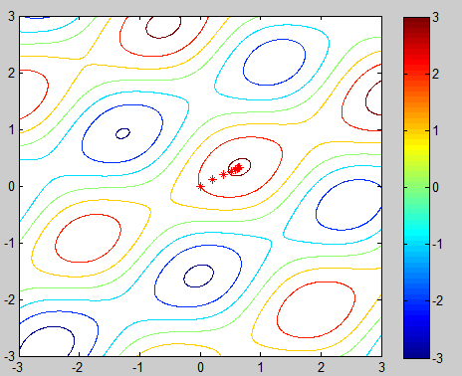

Initial (1,1) initial(0,0)

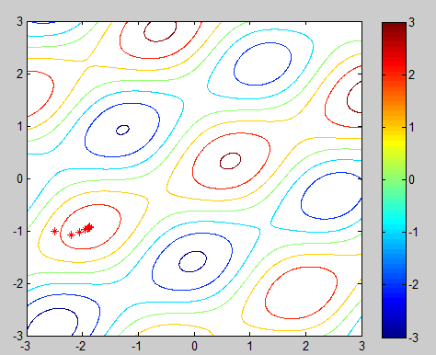 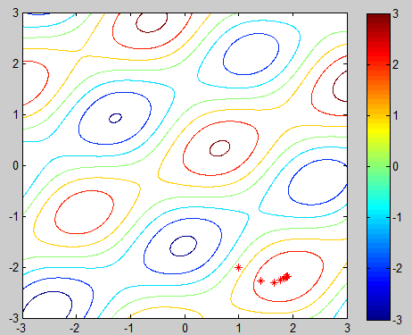

Initial (-2.5,-1) initial (1,-2)

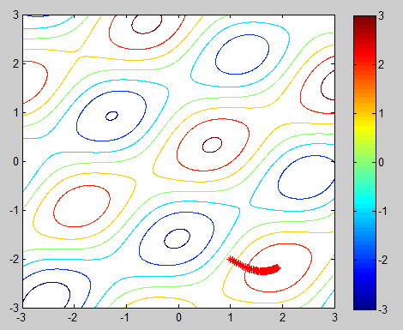 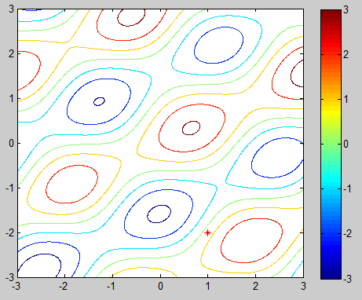

a = 0.01 a=1

matlab code:

%Homework 9 Problem 1

clear all;

close all;

f = inline('sin(2*x+y)+2.*cos(x-2*y)+0.1*(x+y)','x','y');

dx = inline('2*cos(2*x+y)-2*sin(x-2*y)+0.1','x','y');

dy = inline('cos(2*x+y)+4*sin(x-2*y)+0.1','x','y');

x = -3:0.01:3;

y = -3:0.01:3;

%mesh plot

[X,Y]= meshgrid(x,y);

Z = f(X,Y);

figure(1);

surf(X,Y,Z);

shading interp;

%coutour ...

%....

%...

%Gradient of decent

alpha = 1;

%initial point

theta(:,:,1) = [2,-1];

f_value(1) = f(theta(1,1,1),theta(1,2,1));

for i = 2:100

theta(:,:,i) = theta(:,:,i-1) + alpha * [dx(theta(1,1,i-1),theta(1,2,i-1)),dy(theta(1,1,i-1),theta(1,2,i-1))];

%compute the

f_value(i) = f(theta(1,1,i),theta(1,2,i));

end;

%display them

figure(2)

contour(X,Y,Z);

colorbar;

hold on;

for i=1:100

plot(theta(1,1,i),theta(1,2,i),'r*'); hold on;

end;

Problem 2

(a)

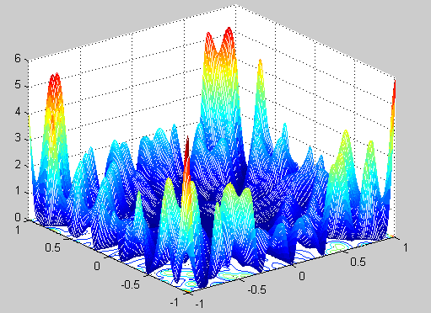 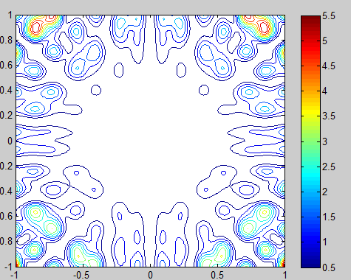

Function plot contour plot

(b)

Initial point a = (0 0); sigma=0.01

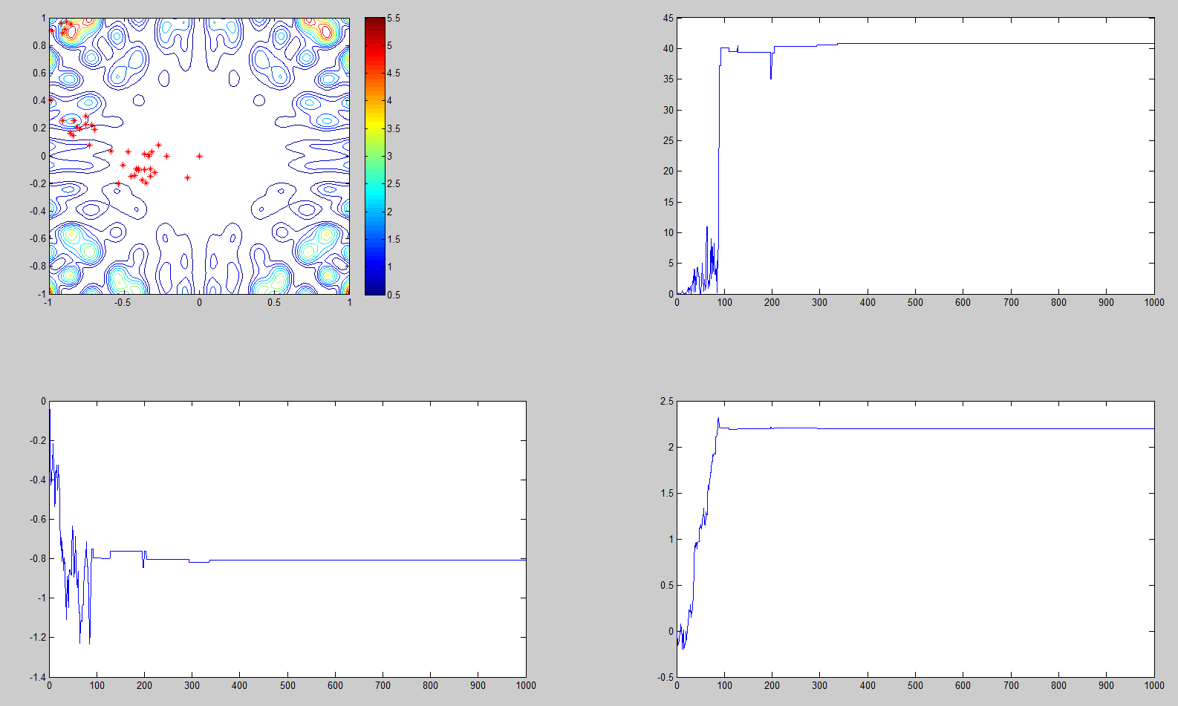

Initial point a = (0.5 0.6); sigma=0.01

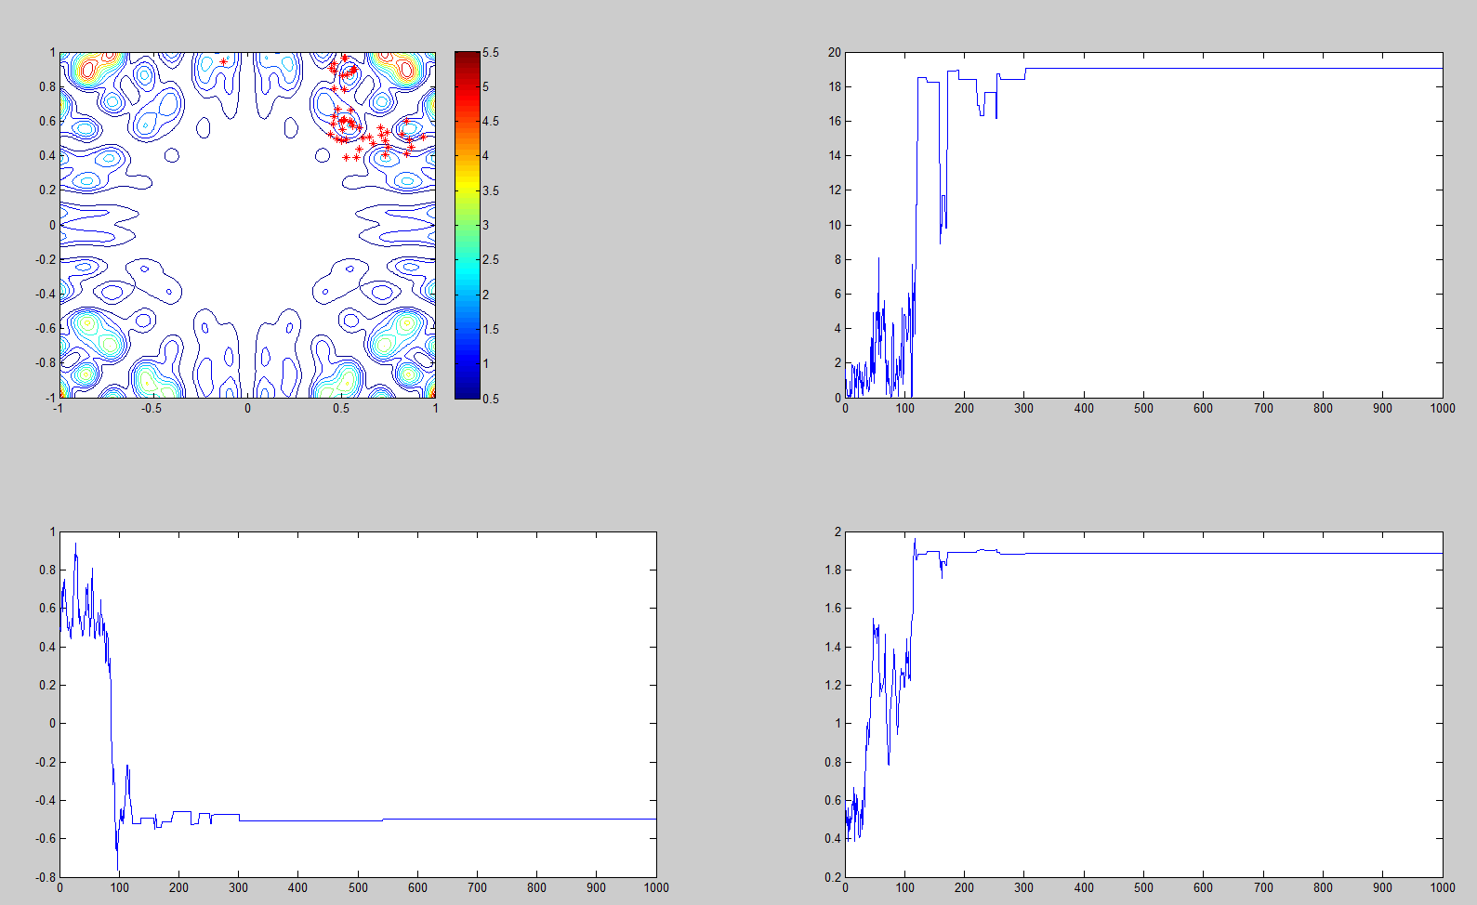

Initial point a = (0.5 0.6); sigma=0.1

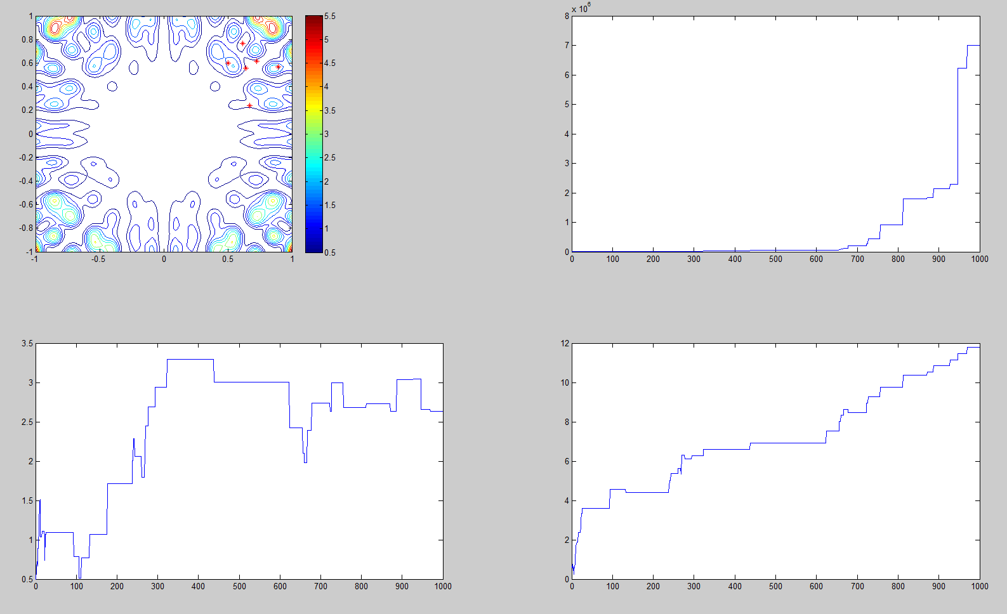

Initial point a = (0 0); sigma=0.1

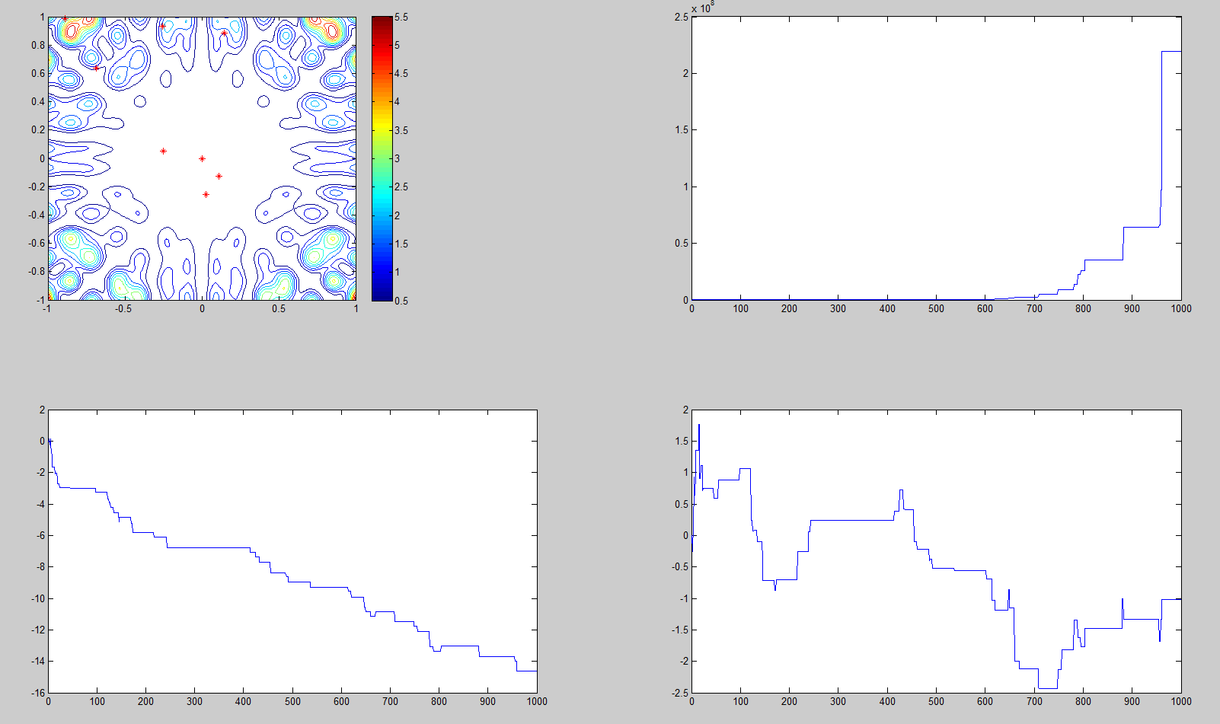

Initial point a = (0 0); sigma=0.001

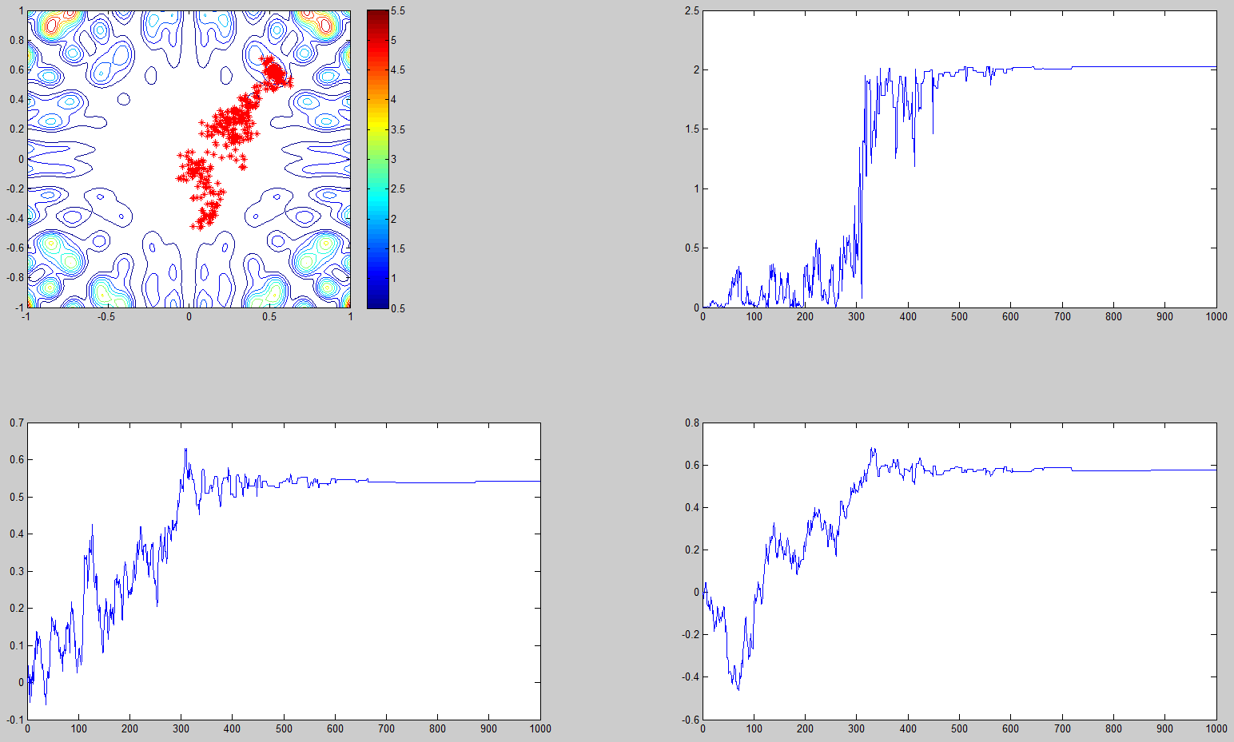

We can see that when sigma is very small, the point spread out very slow to the place with higher altitude. When sigma is larger, the spread speed goes up very fast.

Matlab code:

%answer for homework 9

%problem 2

clear all;

close all;

f = inline('(x.*sin(20*y)+y.*sin(20*x)).^2.*cosh(sin(10*x).*x) + (x.*cos(10*y)-y.*sin(10*x)).^2.*cosh(cos(20*y).*y)','x','y');

[X Y] = meshgrid(-1:0.01:1);

figure(1);

Z = f(X,Y);

% mesh plot

meshc(X,Y,Z);

%for (b)

T(1) = 10;

sigma = [0.001 0; 0 0.001];

%initial point

theta(1,:)=[0 0];

for i=2:1000;

%simulate chi

z = mvnrnd(theta(i-1,:),sigma);

temp = z;

T(i) = T(i-1)*0.99;

temp_p = f(temp(1),temp(2))-f(theta(i-1,1),theta(i-1,2));

temp_tho = exp(temp_p/T(i));

tho = min(1,temp_tho);

r = rand;

if(r>tho) theta(i,:) = theta(i-1,:);

else theta(i,:) = temp;

end;

end;

figure(2);

subplot(2,2,1)

contour(X,Y,Z); hold on;

colorbar;

for i=1:1000

plot(theta(i,1),theta(i,2),'*r');

hold on;

end;

%plot the function

subplot(2,2,2)

plot(1:1000,f(theta(:,1),theta(:,2)));

subplot(2,2,3)

plot(1:1000,theta(:,1));

subplot(2,2,4)

plot(1:1000,theta(:,2))